SIMULATION EXPERIMENT – 9 ❖ Computer-Aided Design and Optimization of a Microwave Impedance-Matching Network and Frequency-Selective Filter

Aim
To design and simulate a microwave impedance-matching network and a 50 Ω frequency-selective filter using MATLAB, and to analyze reflection coefficient, return loss, VSWR, insertion loss, cutoff frequency, bandwidth, passband and stopband characteristics.

Objectives
- To design an impedance-matching network for a complex load of \(75+j25\ \Omega\) at 10 GHz.
- To optimize the matching network for minimum reflection and maximum power transfer.
- To design a 50 Ω frequency-selective filter with a cutoff frequency of 10 GHz.
- To evaluate S₁₁, S₂₁, return loss, insertion loss, passband, stopband and bandwidth from the simulated frequency response.

MATLAB Program
This program does not require RF Toolbox, so it can run in basic MATLAB.

Complete Program
clc;
clear;
close all;

%% =====================================================
% SIMULATION EXPERIMENT - 9
% IMPEDANCE MATCHING AND FREQUENCY SELECTIVE FILTER
%% =====================================================

Z0 = 50; % Reference impedance
ZL = 75 + 1j*25; % Load impedance
f0 = 10e9; % Design frequency
fc = 10e9; % Filter cutoff frequency

f = linspace(8e9,12e9,1001);
w = 2*pi*f;

%% =====================================================
% PART A - IMPEDANCE MATCHING
%% =====================================================

fprintf('============================================\n');
fprintf('PART A - IMPEDANCE MATCHING\n');
fprintf('============================================\n');

%% 1. THEORETICAL REFLECTION COEFFICIENT

GammaL = (ZL-Z0)/(ZL+Z0);

GammaMag = abs(GammaL);

RL_before = -20*log10(GammaMag);

VSWR_before = (1+GammaMag)/(1-GammaMag);

fprintf('\nLoad Impedance = %.2f + j%.2f Ohm\n',...
real(ZL),imag(ZL));

fprintf('|Gamma| = %.4f\n',GammaMag);

fprintf('Return Loss = %.2f dB\n',RL_before);

fprintf('VSWR = %.3f\n',VSWR_before);

%% =====================================================
% 2. MATCHING NETWORK CALCULATION
%% =====================================================

% Normalize load impedance
zL = ZL/Z0;

% Convert to normalized admittance
yL = 1/zL;

g = real(yL);
bL = imag(yL);

% Required shunt susceptance
bmatch = -bL + sqrt(g*(1-g));

% Normalized admittance after matching
ynew = g + 1j*(bL+bmatch);

% Convert back to impedance
znew = 1/ynew;

% Required series reactance
xseries = -imag(znew);

% Actual reactance
Xseries = xseries*Z0;

% Actual shunt susceptance
Bshunt = bmatch/Z0;

% Capacitance
C = Bshunt/(2*pi*f0);

% Inductance
L = Xseries/(2*pi*f0);

fprintf('\n--- MATCHING NETWORK ---\n');

fprintf('Shunt Capacitance = %.4f pF\n',...
C*1e12);

fprintf('Series Inductance = %.4f nH\n',...
L*1e9);

%% =====================================================
% 3. BEFORE MATCHING
%% =====================================================

Zload = ZL*ones(size(f));

Gamma_before = (Zload-Z0)./(Zload+Z0);

S11_before = 20*log10(abs(Gamma_before));

VSWR_before_freq = ...
(1+abs(Gamma_before))./(1-abs(Gamma_before));

%% =====================================================
% 4. AFTER MATCHING
%% =====================================================

% Shunt capacitor impedance
ZC = 1./(1j*w*C);

% Parallel combination
Zparallel = (Zload.*ZC)./(Zload+ZC);

% Series inductor
Zin_match = Zparallel + 1j*w*L;

% Reflection coefficient
Gamma_after = ...
(Zin_match-Z0)./(Zin_match+Z0);

S11_after = 20*log10(abs(Gamma_after));

VSWR_after = ...
(1+abs(Gamma_after))./(1-abs(Gamma_after));

%% =====================================================
% 5. MATCHED INPUT IMPEDANCE AT 10 GHz
%% =====================================================

[~,idx] = min(abs(f-f0));

Zin10 = Zin_match(idx);

fprintf('\n--- MATCHED INPUT ---\n');

fprintf('Input impedance before matching = ');
fprintf('%.2f + j%.2f Ohm\n',...
real(ZL),imag(ZL));

fprintf('Input impedance after matching = ');
fprintf('%.2f + j%.2f Ohm\n',...
real(Zin10),imag(Zin10));

fprintf('S11 before matching = %.2f dB\n',...
S11_before(idx));

fprintf('S11 after matching = %.2f dB\n',...
S11_after(idx));

%% =====================================================
% 6. RETURN LOSS GRAPH
%% =====================================================

figure;

plot(f/1e9,S11_before,'LineWidth',2);

hold on;

plot(f/1e9,S11_after,'--','LineWidth',2);

grid on;

xlabel('Frequency (GHz)');
ylabel('S_{11} (dB)');

title('Return Loss Before and After Matching');

legend('Before Matching','After Matching');

yline(-15,'--');

%% =====================================================
% 7. VSWR GRAPH
%% =====================================================

figure;

plot(f/1e9,VSWR_before_freq,...
'LineWidth',2);

hold on;

plot(f/1e9,VSWR_after,...
'--','LineWidth',2);

grid on;

xlabel('Frequency (GHz)');
ylabel('VSWR');

title('VSWR Before and After Matching');

legend('Before Matching','After Matching');

%% =====================================================
% PART B - FILTER DESIGN
%% =====================================================

fprintf('\n============================================\n');
fprintf('PART B - FILTER DESIGN\n');
fprintf('============================================\n');

%% 8. 5TH ORDER BUTTERWORTH FILTER

N = 5;

% Butterworth magnitude response
H = 1./sqrt(1+(f/fc).^(2*N));

S21 = H;

% Transmission in dB
S21_dB = 20*log10(abs(S21));

% Ideal lossless reflection coefficient
S11_mag = sqrt(1-abs(S21).^2);

S11_dB = 20*log10(abs(S11_mag));

%% =====================================================
% 9. INSERTION LOSS
%% =====================================================

IL = -S21_dB;

%% =====================================================
% 10. CUTOFF FREQUENCY
%% =====================================================

[~,idx3] = min(abs(S21_dB+3));

fc_sim = f(idx3);

fprintf('\n--- FILTER RESULTS ---\n');

fprintf('Specified cutoff = %.2f GHz\n',...
fc/1e9);

fprintf('Simulated cutoff = %.4f GHz\n',...
fc_sim/1e9);

%% =====================================================
% 11. PASSBAND
%% =====================================================

passband_index = find(S21_dB >= -3);

fL = f(passband_index(1));
fH = f(passband_index(end));

BW = fH-fL;

fprintf('Lower passband frequency = %.4f GHz\n',...
fL/1e9);

fprintf('Upper passband frequency = %.4f GHz\n',...
fH/1e9);

fprintf('Bandwidth = %.4f GHz\n',...
BW/1e9);

%% =====================================================
% 12. PERCENTAGE DEVIATION
%% =====================================================

deviation = abs(fc_sim-fc)/fc*100;

fprintf('Cutoff frequency deviation = %.4f %%\n',...
deviation);

%% =====================================================
% 13. INSERTION LOSS GRAPH
%% =====================================================

figure;

plot(f/1e9,S21_dB,'LineWidth',2);

grid on;

xlabel('Frequency (GHz)');
ylabel('S_{21} (dB)');

title('Filter S_{21} / Transmission Response');

hold on;

yline(-3,'--');

xline(10,'--');

legend('S_{21}','-3 dB','10 GHz');

%% =====================================================
% 14. FILTER S11 GRAPH
%% =====================================================

figure;

plot(f/1e9,S11_dB,'LineWidth',2);

grid on;

xlabel('Frequency (GHz)');
ylabel('S_{11} (dB)');

title('Filter S_{11} / Return Loss');

%% =====================================================
% 15. S11 AND S21 TOGETHER
%% =====================================================

figure;

plot(f/1e9,S11_dB,...
'LineWidth',2);

hold on;

plot(f/1e9,S21_dB,...
'--','LineWidth',2);

grid on;

xlabel('Frequency (GHz)');
ylabel('Magnitude (dB)');

title('Filter S_{11} and S_{21}');

legend('S_{11}','S_{21}');

%% =====================================================
% 16. INSERTION LOSS GRAPH
%% =====================================================

figure;

plot(f/1e9,IL,'LineWidth',2);

grid on;

xlabel('Frequency (GHz)');
ylabel('Insertion Loss (dB)');

title('Filter Insertion Loss');

%% =====================================================
% FINAL RESULTS
%% =====================================================

fprintf('\n============================================\n');
fprintf('FINAL RESULTS\n');
fprintf('============================================\n');

fprintf('Design Frequency = %.2f GHz\n',...
f0/1e9);

fprintf('Reference Impedance = %.2f Ohm\n',...
Z0);

fprintf('Load Impedance = %.2f + j%.2f Ohm\n',...
real(ZL),imag(ZL));

fprintf('|Gamma| before matching = %.4f\n',...
GammaMag);

fprintf('Return Loss before matching = %.2f dB\n',...
RL_before);

fprintf('Matched Input Impedance = ');
fprintf('%.2f + j%.2f Ohm\n',...
real(Zin10),imag(Zin10));

fprintf('Filter Cutoff Frequency = %.4f GHz\n',...
fc_sim/1e9);

fprintf('Filter Bandwidth = %.4f GHz\n',...
BW/1e9);

fprintf('Cutoff Deviation = %.4f %%\n',...
deviation);

Output

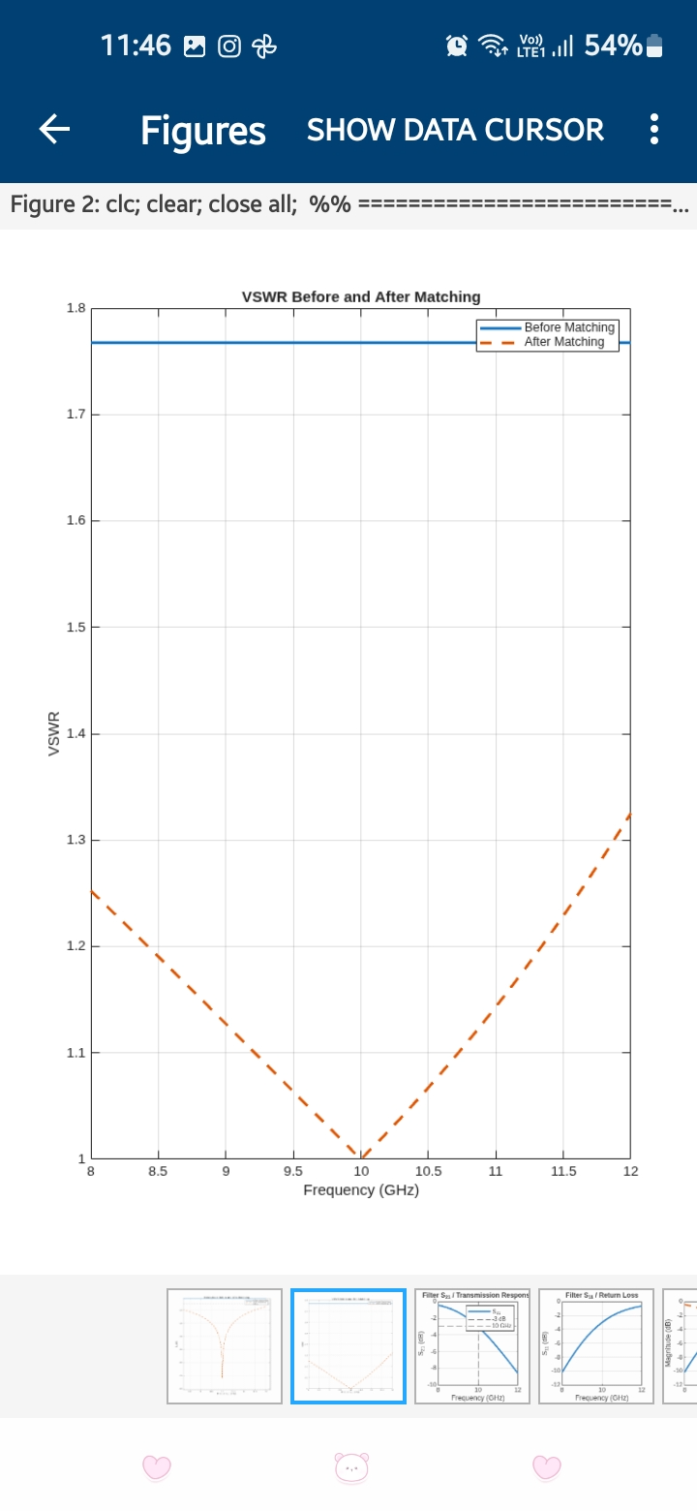
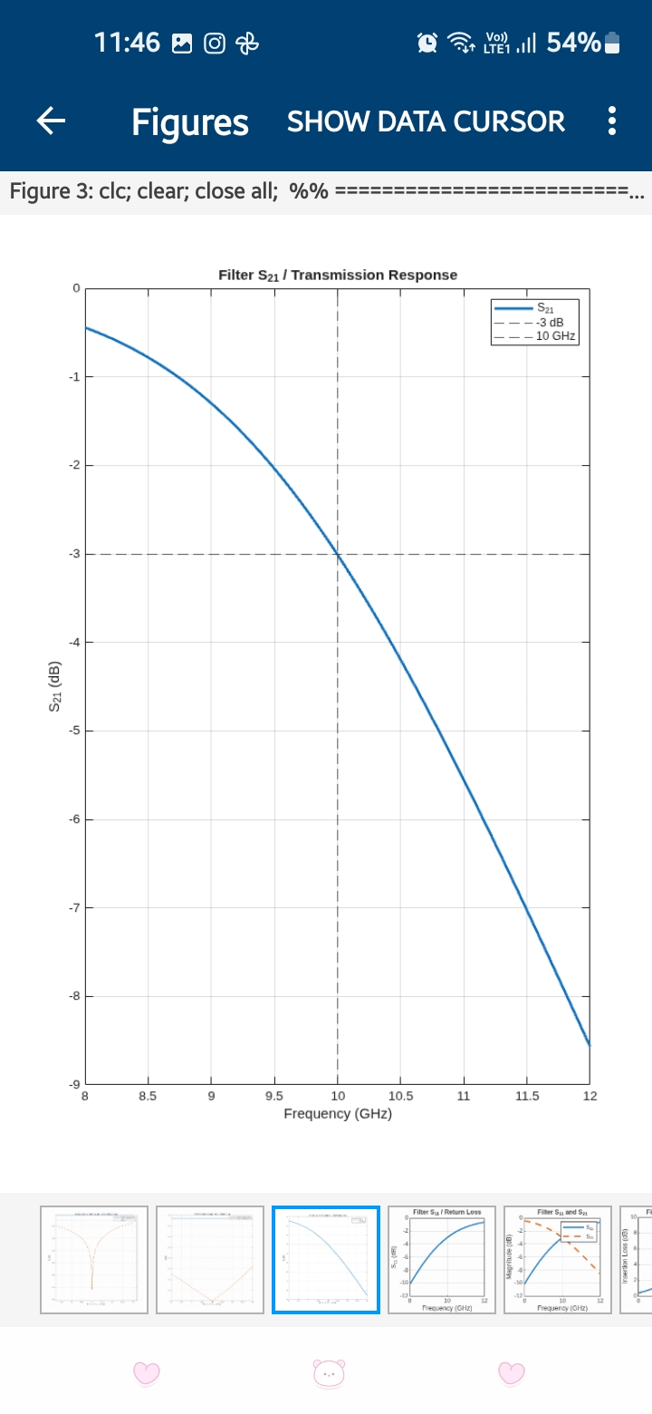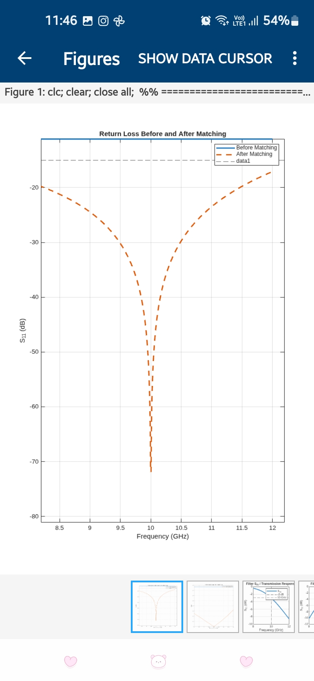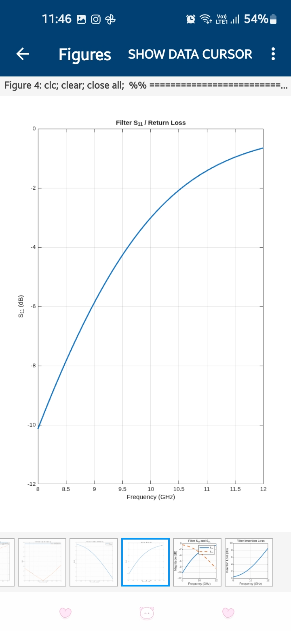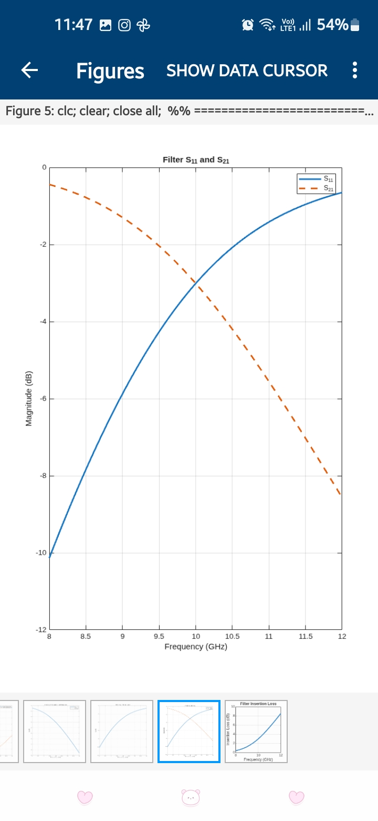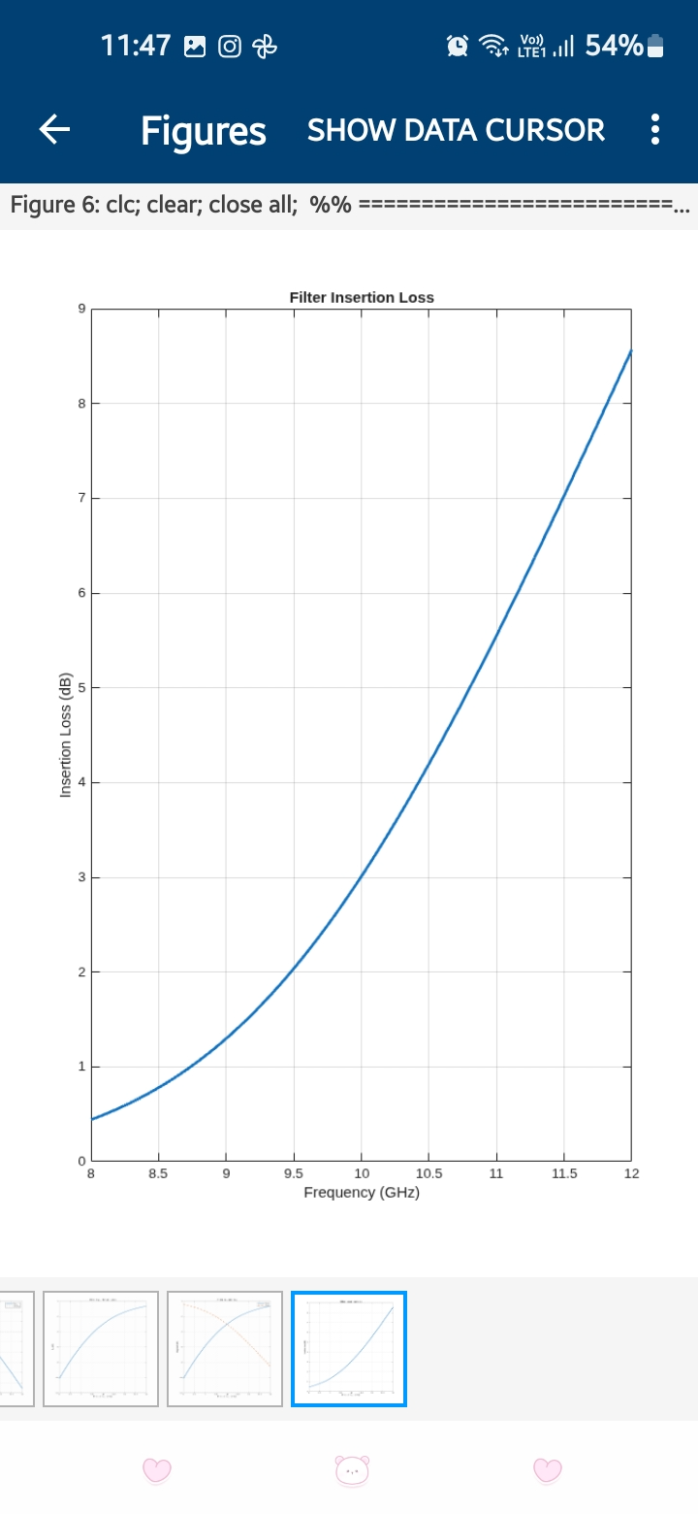

Reflection
The simulation helped me understand the importance of impedance matching in microwave systems. The complex load of \(75+j25\ \Omega\) produced reflection when connected to a 50 Ω system. The matching network reduced the reflection and transformed the input impedance closer to the required 50 Ω value. The filter simulation helped me understand S₁₁ and S₂₁ characteristics and how the cutoff frequency separates the passband from the stopband.

Result
The microwave impedance-matching network was successfully designed for a 75+j25 Ω load connected to a 50 Ω system at 10 GHz. The reflection coefficient, return loss and VSWR were calculated before and after matching. The input impedance was transformed close to 50+j0 Ω at the design frequency. A 5th-order 50 Ω Butterworth low-pass filter with a cutoff frequency of approximately 10 GHz was also simulated. The S₁₁, S₂₁, return loss, insertion loss, passband, stopband and bandwidth characteristics were successfully obtained and analyzed.

